
Department of Computer Science and Engineering DevOps Lab - L3

Lab Assignment No: 14
Name of Student | Atharva Rale
PRN | 23070122174
Batch | 2023 - 2027
Class | CSE – B1
Academic Year & Semester | 2026 - 2027, 7th Semester
Title of Assignment | CI/CD — Jenkins Pipeline building Docker Image
Implementation & Theory | 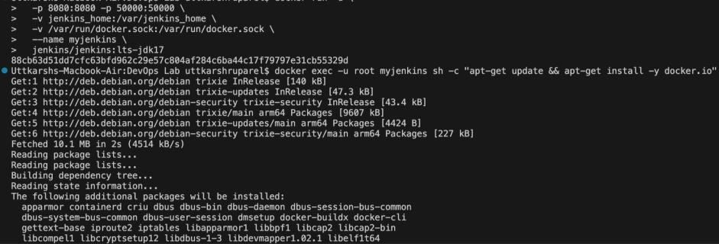  Jenkins container recreated with Docker access — Stopped and removed the existing Jenkins container, then re-ran it with the host's Docker socket mounted (-v  /var/run/docker.sock:/var/run/docker.sock), since Jenkins runs inside its own container and has no Docker daemon of its own.

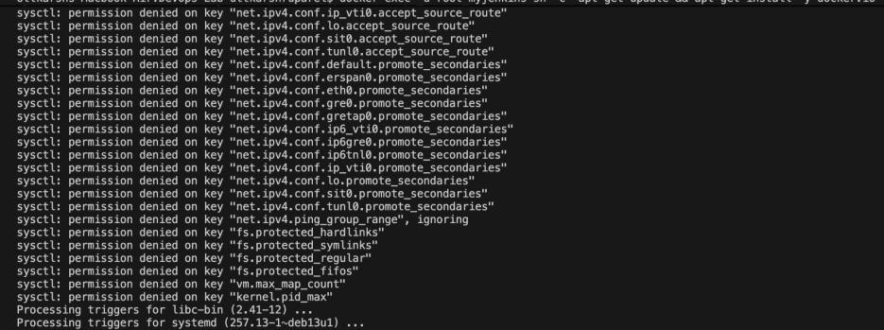
Docker CLI installed inside Jenkins — Installed docker.io inside the running Jenkins container via apt-get, then verified with docker
--version that the CLI could talk out through the mounted socket.

Repo pushed — Committed and pushed local work (assignments 8-13) to the Devops-Coursework GitHub repo so Jenkins had something to check out and build.

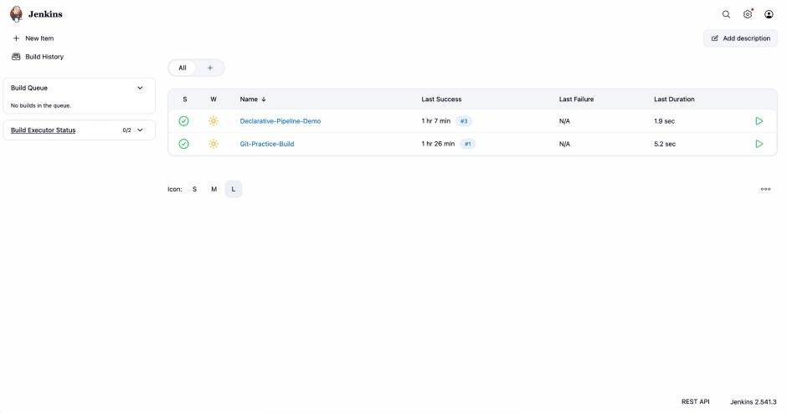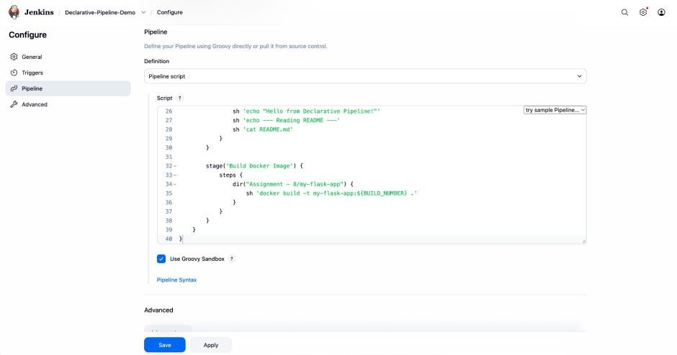
Pipeline updated with Build Docker Image stage — Added a new stage to the existing Declarative-Pipeline-Demo pipeline that

changes into the Assignment - 8/my-flask-app directory and runs docker build -t my-flask-app:${BUILD_NUMBER} ., auto-tagging the image per build.

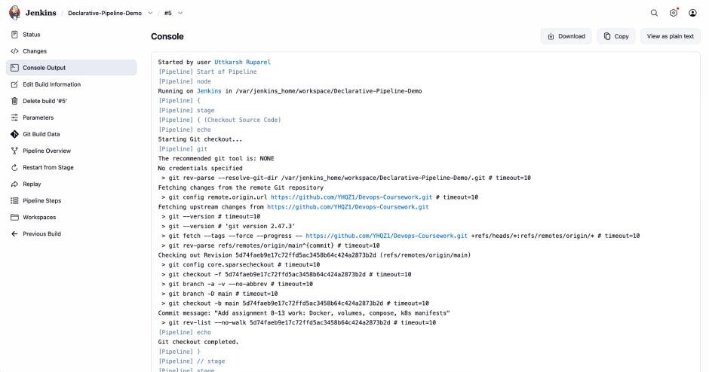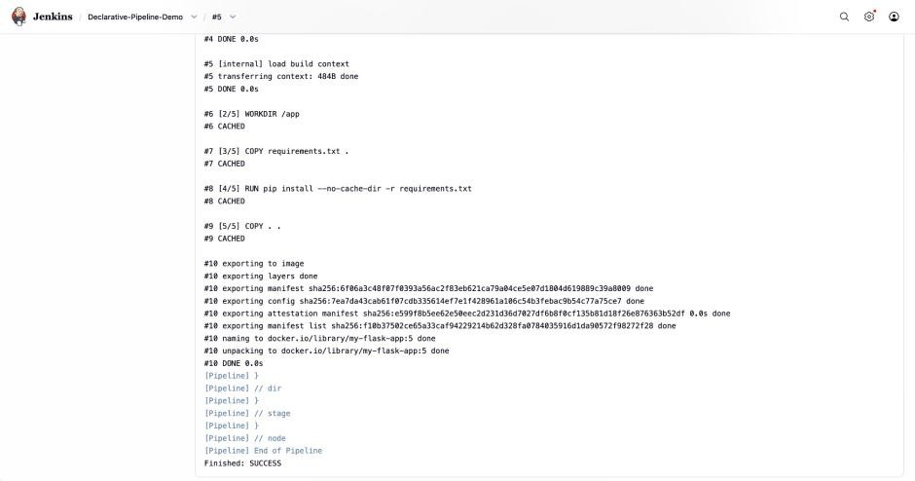
Successful build — Re-ran the pipeline; all stages completed, and the Build Docker Image stage successfully built and tagged
my-flask-app:5, with the full pipeline finishing SUCCESS.

